1. Create one VPC, with 1 one public subnet and 1 private subnet.



1. Enable VPC peering for cross region.

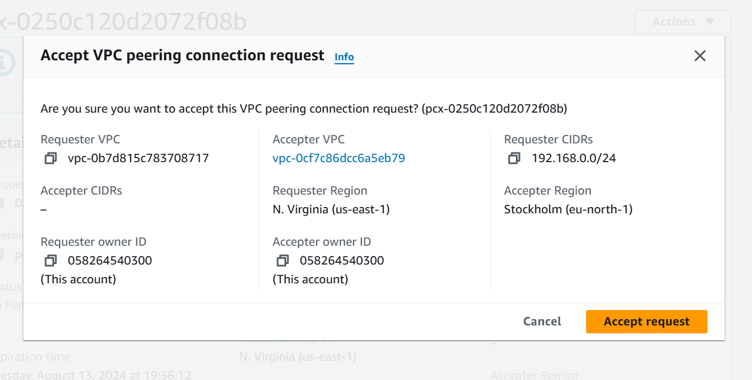

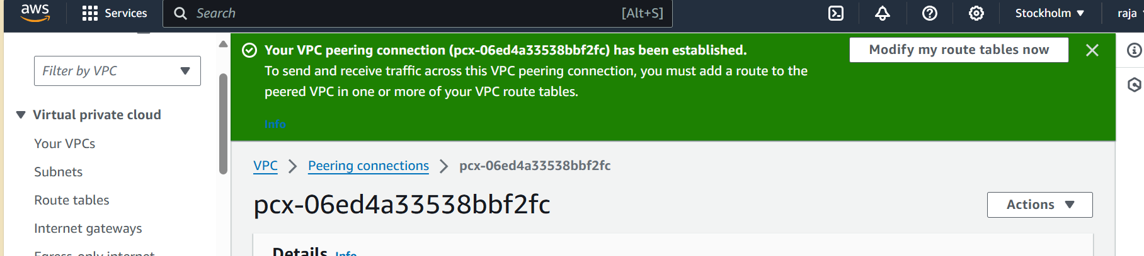

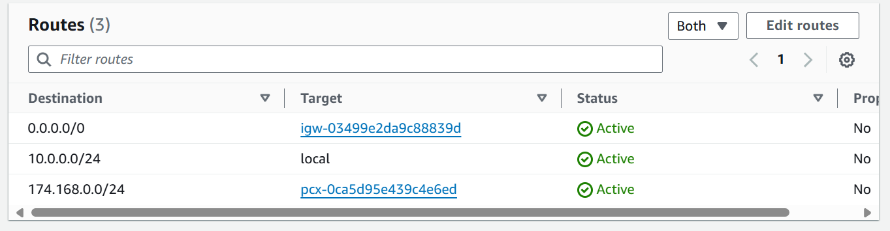

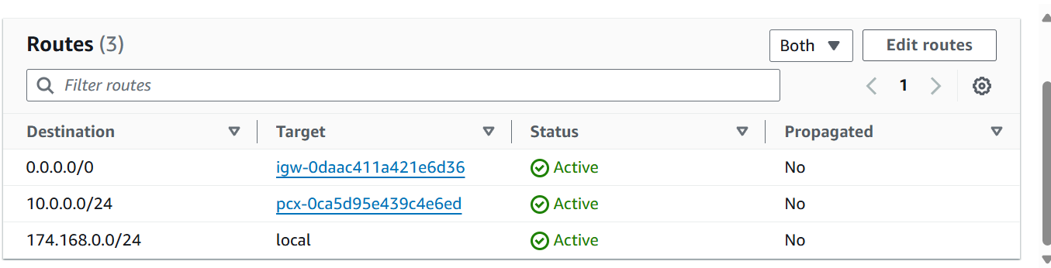

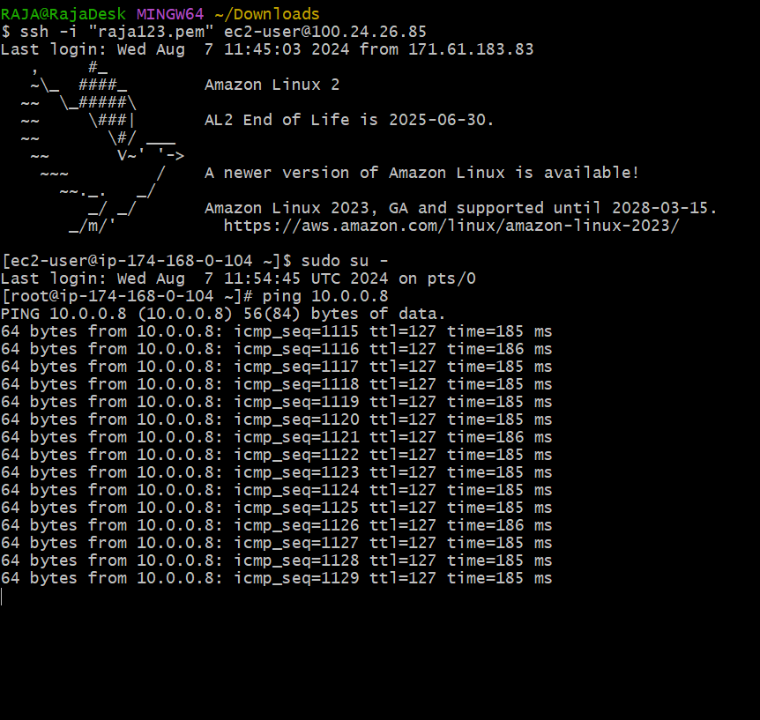

3)Enable VPC peering for cross account. (You can collaborate with your friend and do this task).

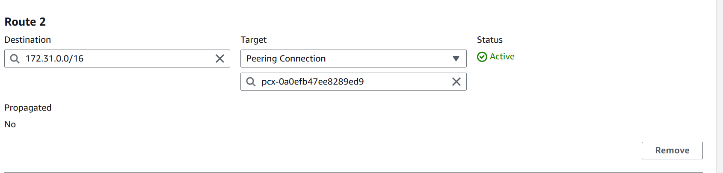



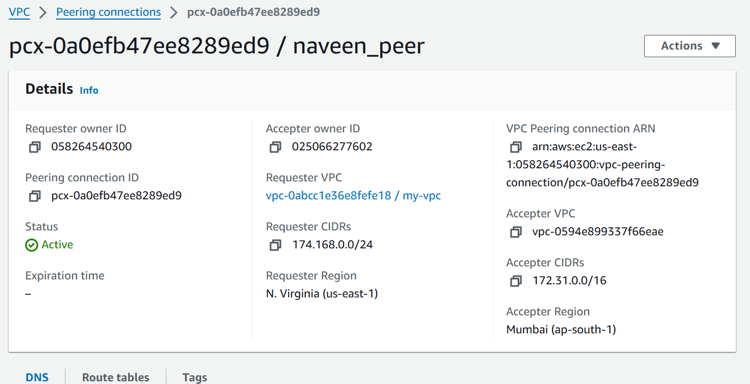

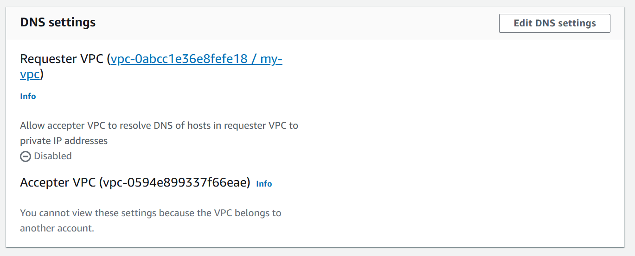

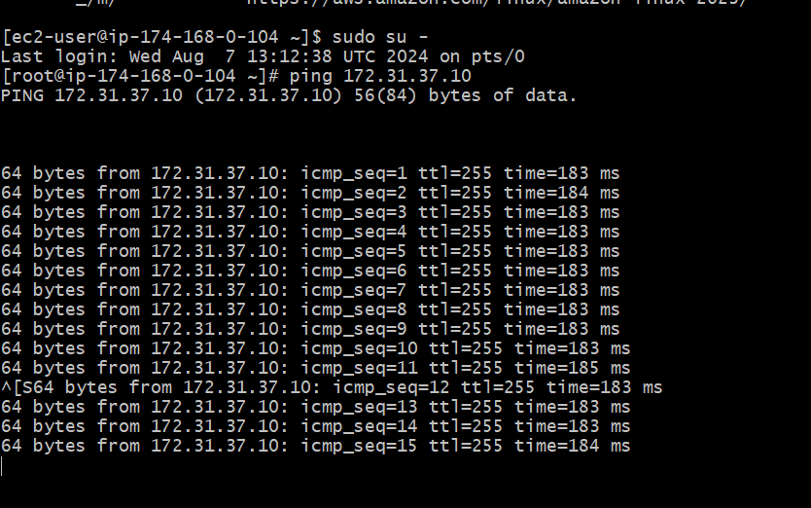

4) Bash script to setup one vpc,1 public and 1 private subnet with IGW, RT and need to launch one ec2 in public and one ec2 in private in `SEOUL REGION` ONLY.

#!/bin/bash# Variables  
VPC_CIDR_BLOCK="192.68.0.0/16"  
PUBLIC_SUBNET_CIDR_BLOCK="192.68.0.0/28"  
PRIVATE_SUBNET_CIDR_BLOCK="192.68.0.16/28"  
REGION="us-east-1"  
VPC_TAG_NAME="MyVPC-vini"  
PUBLIC_SUBNET_TAG_NAME="PublicSubnet"  
PRIVATE_SUBNET_TAG_NAME="PrivateSubnet"# Create VPC  
VPC_ID=$(aws ec2 create-vpc --cidr-block $VPC_CIDR_BLOCK --region $REGION --query 'Vpc.VpcId' --output text)  
echo "Created VPC: $VPC_ID"# Tag VPC  
aws ec2 create-tags --resources $VPC_ID --tags Key=Name,Value=$VPC_TAG_NAME --region $REGION  
echo "Tagged VPC with Name=$VPC_TAG_NAME"# Create Public Subnet  
PUBLIC_SUBNET_ID=$(aws ec2 create-subnet --vpc-id $VPC_ID --cidr-block $PUBLIC_SUBNET_CIDR_BLOCK --region $REGION --query 'Subnet.SubnetId' --output text)  
echo "Created Public Subnet: $PUBLIC_SUBNET_ID"# Tag Public Subnet  
aws ec2 create-tags --resources $PUBLIC_SUBNET_ID --tags Key=Name,Value=$PUBLIC_SUBNET_TAG_NAME --region $REGION  
echo "Tagged Public Subnet with Name=$PUBLIC_SUBNET_TAG_NAME"# Create Private Subnet  
PRIVATE_SUBNET_ID=$(aws ec2 create-subnet --vpc-id $VPC_ID --cidr-block $PRIVATE_SUBNET_CIDR_BLOCK --region $REGION --query 'Subnet.SubnetId' --output text)  
echo "Created Private Subnet: $PRIVATE_SUBNET_ID"# Tag Private Subnet  
aws ec2 create-tags --resources $PRIVATE_SUBNET_ID --tags Key=Name,Value=$PRIVATE_SUBNET_TAG_NAME --region $REGION  
echo "Tagged Private Subnet with Name=$PRIVATE_SUBNET_TAG_NAME"# Create Internet Gateway  
IGW_ID=$(aws ec2 create-internet-gateway --region $REGION --query 'InternetGateway.InternetGatewayId' --output text)  
echo "Created Internet Gateway: $IGW_ID"# Attach Internet Gateway to VPC  
aws ec2 attach-internet-gateway --internet-gateway-id $IGW_ID --vpc-id $VPC_ID --region $REGION  
echo "Attached Internet Gateway to VPC"# Create Route Table for Public Subnet  
PUBLIC_ROUTE_TABLE_ID=$(aws ec2 create-route-table --vpc-id $VPC_ID --region $REGION --query 'RouteTable.RouteTableId' --output text)  
echo "Created Route Table for Public Subnet: $PUBLIC_ROUTE_TABLE_ID"# Create Route for Public Subnet Route Table  
aws ec2 create-route --route-table-id $PUBLIC_ROUTE_TABLE_ID --destination-cidr-block 0.0.0.0/0 --gateway-id $IGW_ID --region $REGION  
echo "Created Route for Internet Access in Public Subnet Route Table"# Associate Public Subnet with Public Route Table  
aws ec2 associate-route-table --subnet-id $PUBLIC_SUBNET_ID --route-table-id $PUBLIC_ROUTE_TABLE_ID --region $REGION  
echo "Associated Public Subnet with Public Route Table"# Create Route Table for Private Subnet  
PRIVATE_ROUTE_TABLE_ID=$(aws ec2 create-route-table --vpc-id $VPC_ID --region $REGION --query 'RouteTable.RouteTableId' --output text)  
echo "Created Route Table for Private Subnet: $PRIVATE_ROUTE_TABLE_ID"# Associate Private Subnet with Private Route Table  
aws ec2 associate-route-table --subnet-id $PRIVATE_SUBNET_ID --route-table-id $PRIVATE_ROUTE_TABLE_ID --region $REGION  
echo "Associated Private Subnet with Private Route Table"